User Acceptance Testing (UAT) Template
Date | 12 September 2026
Project Name | Employee Raise Issue
Maximum Marks

Project Overview:
Project Name: Employee Raise Issue
Project Description: A ServiceNow application that allows employees to raise issues through a Record Producer. Issues are categorized, assigned priority, and managed using workflows, notifications, and reports.
Project Version: Version 1.0
Testing Period: 13 Sept 2026 to 14 Sept 2026
Testing Scope:

Features and Functionalities to be Tested
- Employee Raise Issue Record Producer
- Issue creation and submission
- Category and Subcategory dependent fields
- Mandatory field validation
- Priority and State management
- List filtering (State, Category, Priority)
- Reports and Notifications

Requirements to be Tested
- Employees can submit a new issue successfully.
- The system stores issue details in the custom table.
- Subcategory changes based on the selected Category.
- Mandatory fields prevent incomplete submissions.
- Users can filter and view issues by State and Priority.
- Admin can update the issue status (Accepted, In Progress, Closed).

Testing Environment:
platform: ServiceNow
URL/Location: https://developer.servicenow.com/dev.do
Credentials (if required): Not included in the document for security reasons

Test Cases:

Test Case ID | Test Scenario | Test Steps | Expected Result | Actual Result | Pass/Fail
TC-001 | Create a new employee issue | 1. Open Record Producer  2. Enter issue details  3. Click Submit | A new issue record is created successfully | Record created successfully | Pass
TC-002 | Validate mandatory fields | 1. Open Record Producer  2. Leave required fields empty  3. Click Submit | System displays mandatory field validation messages | Validation message displayed | Pass
TC-003 | Verify Category & Subcategory | 1. Select Category = Network  2. Check Subcategory list  3. Select VPN | Only related subcategories are displayed | Correct subcategory displayed | Pass
TC-004 | Verify State update | 1. Open an existing issue  2. Change State to Accepted  3. Save the record | State is updated successfully | State updated successfully | Pass
TC-005 | Verify list filtering | 1. Open Employee Raise Issue lis  t 2. Apply State = Accepted filter  3. Run filter | Only accepted records are displayed | Filter returned correct records | Pass
Bug Tracking:
Bug ID | Bug Description | Steps to reproduce | Severity | Status | Additional feedback
BG-001 | Subcategory was not displayed until Category was selected. | 1. Open Record Producer.  2. Leave Category empty.  3. Check the Subcategory field. | Low | Closed | Dependency configuration was corrected and the issue was resolved.
BG-002 | Mandatory field validation was triggered when Description was left blank. | 1. Open Record Producer  . 2. Leave Description empty.  3. Click Submit. | Low | Closed | Validation worked as expected; no code changes required.

Sign-off:
Tester Name: Repalle Himaja Sri
Date: 12 September 2026
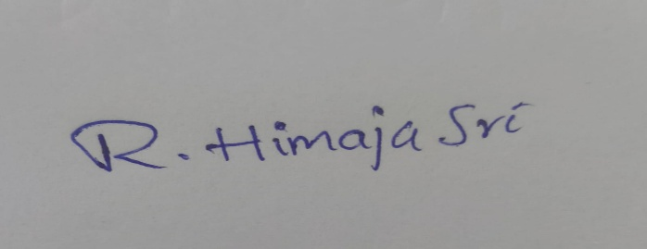
Signature:

Notes:

- Ensure that all test cases cover both positive and negative scenarios.
- Encourage testers to provide detailed feedback, including any suggestions for improvement.
- Bug tracking should include details such as severity, status, and steps to reproduce.
- Obtain sign-off from both the project manager and product owner before proceeding with deployment.

